Comparative Evaluation of Interfacial Solar Evaporator Designs for Critical Mineral Brine Pre-Concentration

Patrick Song, Princeton High School, Princeton, New Jersey, United States of America
Instructor: Jennifer Smolyn, Princeton High School, Princeton, New Jersey, United States of America

Comparative Evaluation of Interfacial Solar Evaporator Designs for Critical Mineral Brine Pre-Concentration

Patrick Song, Princeton High School

Abstract
Demand for critical minerals such as lithium and magnesium is skyrocketing due to the global green energy transition, decarbonization efforts, and growing supply-chain concerns. Conventional evaporation-based mineral recovery relies on passive solar heating of large evaporation ponds, a process that is highly inefficient, land-intensive, and environmentally damaging. Interfacial solar evaporation (ISE) offers a potential alternative by localizing heat generation at the liquid-air interface, enabling increased evaporation rates without directly heating the full brine volume.
This study compares three representative ISE surfaces: (1) a porous carbon felt salt-backflow structure (Structure A), (2) a graphite-polyurethane Janus structure (Structure B), and (3) a capillary-driven directional crystallization structure (Structure C). Devices were evaluated using synthetic MgCl₂, NaCl, and LiCl under elevated-temperature, low-humidity laboratory conditions. Performance was assessed using model-corrected water evaporation rate normalized by exposed photothermal area (g H₂O evaporated/day/cm²), material cost-normalized performance (g H₂O evaporated/day/$), and visible structural integrity. Quantitative comparisons were interpreted primarily within individual experimental trials as some environmental conditions differed among brine experiments.
Performance was condition- and metric- dependent. In both tested MgCl₂ conditions, Structure A achieved the highest area-normalized evaporation rate while Structure B was the lowest. Structures A and B achieved no consistent ordering across the two NaCl configurations. Structure B achieved the highest area-normalized evaporation rate in both LiCl configurations. Cost-normalized rankings differed, with Structure C achieving the highest cost-efficiency metric in both MgCl₂ trials and Structure B in all NaCl and LiCl trials. Structure A maintained the highest total-volume evaporated within each brine condition and retained visible material integrity, although salt accumulation caused functional failure during NaCl testing. Visible material changes were qualitatively observed in graphite-containing Structure B and Structure C, where carbonaceous material was released. The chemical composition was not determined.
These findings demonstrate that tested material–architecture designs involved tradeoffs among whole-device throughput, area-normalized evaporation rate, cost-efficiency, fouling, and qualitative material stability under all tested conditions. These results support further investigation of hybrid carbon felt/Janus architectures as candidate designs for brine pre-concentration rather than establishing a universally optimal architecture.

Keywords: interfacial solar evaporation; brine pre-concentration; critical minerals; lithium chloride; magnesium chloride; photothermal materials
Table of Contents
Abstract 2
Keywords 3
Introduction 3
Methodology 5
Results 12
Discussion 19
Performance Trade-offs Among Tested Material–Architecture Designs 19
Salt Fouling and Material Degradation 20
Area-normalized Evaporation Rate vs. Cost-Normalized Performance for Practical Applications 22
MgCl₂ Trials – Analysis of Structure B Performance 23
LiCl Trials – Commercial Relevance and High-Concentration Evaporation 25
Limitations in Experimental Design 26
Future Directions 28
Conclusions 29
Acknowledgements 30
Bibliography 32

Introduction
Critical minerals are substances or materials that have high supply-chain vulnerabilities while serving an essential function in one or more energy technologies [1]. Common examples include lithium, magnesium, silicon, cobalt, nickel, and copper. In 2025, the Global Critical Minerals Outlook reported that China continues to be the leading refiner for 19 out of 20 critical minerals, averaging 70% market share [2]. Amidst skyrocketing demands for new forms of green energy, consumer industries, and national defense, continued reliance on limited suppliers poses huge risks. Demand for lithium alone is expected to increase by sixfold from 0.5 million metric tons of lithium carbonate equivalent (LCE) to 3 million metric tons by 2030 [3]. This, alongside concentrated global refining capacity, has intensified the need for more sustainable and reliable critical mineral extraction technologies.
Conventional lithium production can impose substantial water, land, energy, and ecosystem burdens, although the magnitude of these impacts varies considerably with resource type and processing route [3-5]. Evaporation-based brine concentration is also slow and requires extensive pond area, motivating interest in alternative concentration and extraction technologies. Conventional magnesium mining and extraction methods are similarly unsustainable. Electrolytic separation of molten magnesium salts releases massive amounts of carbon dioxide while carrying significant safety risks [6, 7]. Alternative methods of extracting magnesium salts – such as from naturally occurring brine – require the addition of various acidic reactants, carrying risk of leakage into local soil and ecosystems [8]. Together, these limitations highlight the need for more efficient and environmentally sustainable extraction technologies.
Interfacial solar evaporation (ISE) offers a promising alternative. By taking advantage of photothermal materials to absorb incident solar radiation, ISE devices localize heat generation near the liquid-gas interface of brine pools rather than heating the entire bulk solution [3]. Conventional bulk heating methods can suffer substantial conductive and convective heat losses, with energy transfer efficiency often below 40% [9]. By contrast, solar-to-vapor efficiencies above 90% have been reported for optimized laboratory ISE systems [9,10]. At sufficient scale, such systems may reduce land and energy consumption associated with conventional evaporation-based mineral concentration.
At the same time, current ISE technologies face certain challenges. Specifically, the high salinity of brines (reported at 34.7% in the Salar de Atacama reservoir, for example, compared to 3.5% in seawater) risks surface fouling, defined here as the accumulation of salts or other deposits that obstruct or alter the evaporation surface, as well as salt precipitation [11]. Previous studies have investigated a range of anti-fouling architectures and photothermal materials. This study evaluates three representative material-architecture designs: a carbon felt salt backflow surface (Structure A), a polyurethane-graphite Janus design (Structure B), and a graphite-polyurethane directional-crystallization precipitation structure incorporating coarse sponge (Structure C). As these designs differ in photothermal material, supporting layers, geometry, and liquid-contact configuration, the present comparison in this study does not isolate architecture or material as an independent variable. Instead, it evaluates performance tradeoffs of the complete device designs as constructed.
Structure A utilizes porous carbon felt to promote passive salt backflow generated by concentration gradients during evaporation [12]. As water is removed from the evaporation interface, local salt concentration increases. A porous, continually wetted material can thus facilitate diffusion of concentrated solution back to the bulk brine, potentially delaying surface precipitation.
Structure B uses buoyant polyurethane foam to physically separate the graphite photothermal layer from the bulk brine while supplying liquid to the upper surface through capillary transport. This Janus configuration is designed to localize heat near the evaporation interface while reducing direct contact between the photothermal layer and bulk solution.
Structure C incorporates peripheral coarse-sponge regions around a central graphite-polyurethane photothermal region. Differences in pore structure are intended to alter capillary transport and promote directional crystallization away from the central evaporation area [13]. Such directional crystallization architectures could potentially facilitate salt collection while limiting photothermal-surface fouling.
This study compares three ISE material–architecture designs using MgCl₂, NaCl, and LiCl brines under elevated-temperature, low-humidity laboratory conditions. Performance was evaluated using (1) area-normalized water evaporation rate, (2) material cost-normalized performance, and (3) observed material integrity. Because photothermal material and device architecture varied together among Structures A–C, the study evaluates complete tested designs rather than independently quantifying material or architectural effects. The experiments directly examine evaporation-driven brine pre-concentration, an upstream process relevant to critical-mineral recovery. The objective was to identify performance trade-offs among the tested designs and determine how their relative performance varied under the tested single-salt conditions.

Methodology
Experiments were conducted in insulated environmental chambers designed to provide elevated-temperature, low-humidity conditions for laboratory evaluation of interfacial solar evaporation. Each chamber consisted of a black polyester enclosure illuminated by a nominal 100 W reptile heat lamp positioned above the experimental beaker. Temperature and relative humidity were monitored using a digital temperature/relative humidity sensor. In reduced-scale follow-up experiments, all experimental groups were placed within a single chamber to reduce chamber-to-chamber variability. Incident irradiance at the evaporator surface was not directly measured in the present study. A representative original-scale experimental setup is shown in Figure 1.
During only the first LiCl experiments, a portable USB fan was introduced to provide airflow across the experimental groups. Because airflow was not used during the MgCl₂ or NaCl experiments, evaporation rates should be compared primarily within each brine condition rather than quantitatively across brine types. Portable fans were placed at the base of the chamber with a 1-2cm distance from the experimental beaker and maintained throughout the first LiCl experiment to simulate real-world wind and boost evaporation.
Synthetic MgCl₂, NaCl, and LiCl brines were prepared from laboratory-grade salts at concentrations intended to represent chemically relevant high-salinity conditions while simplifying the brine chemistry to single-salt systems. Initial weight percent, molarities, and experimental container sizes are summarized in Table 1. Reduced-scale follow-up experiment brines were prepared to closely match the corresponding original compositions and stored in 250mL beakers. Actual preparation compositions were used in subsequent thermodynamic calculations. Experiments continued until structural failure, negligible evaporation, or completion of the intended observation period.
Brine Type | Wt% | Molarity | Original Trial Beaker Size
MgCl₂ | 14.7% | 1.74 | 1L
NaCl | 23.7% | 4.78 | 600mL
LiCl | 34.8% | 10.0 | 400mL
Table 1: Initial composition of synthetic single-salt brine, wt%, molarity, and size of beaker used in original-scale experiments. Molarity refers to the initially prepared solution before evaporation.
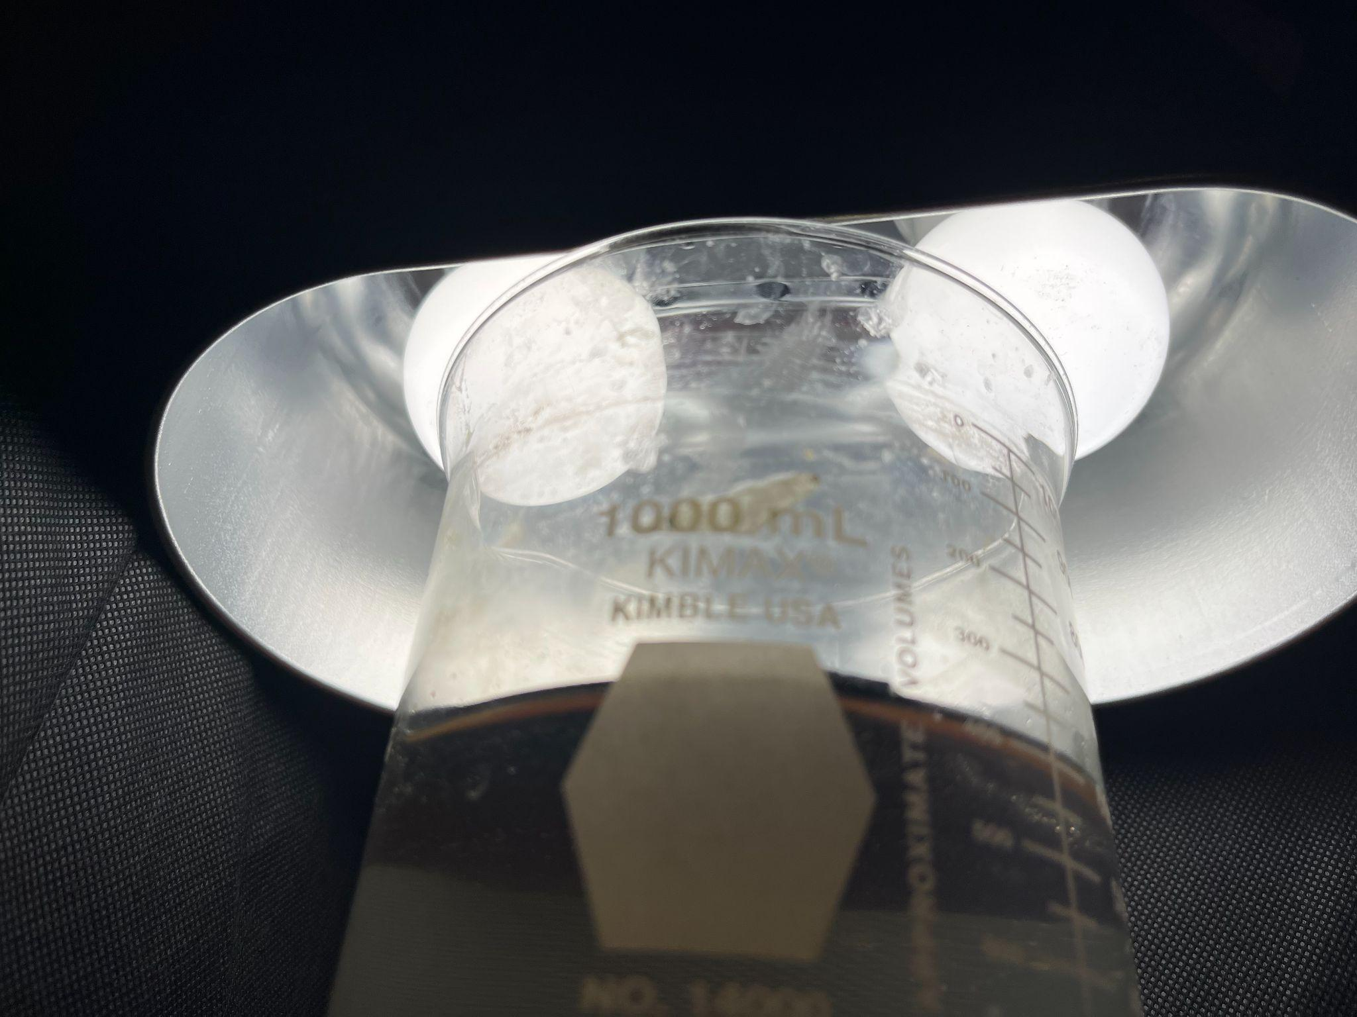
Figure 1: MgCl₂ experimental setup. Structure B is shown inside the beaker under a heat lamp and covered by a polyester dome.

The three brines were not concentration-matched; rather, the selected compositions represented distinct high-salinity conditions for each single-salt system. Consequently, comparisons among brine types reflect differences in both salt identity and starting concentration and were not used to isolate the effect of salt chemistry alone. Container capacity is also reported because vessel dimensions constrained feasible device dimensions and exposed photothermal area.
To construct Structure A, porous carbon felt was cut to dimensions appropriate for the experimental container to maximize photothermal coverage. The carbon felt was positioned in direct contact with the brine while maintaining an exposed photothermal region at the liquid-air interface. Parts of the felt were submerged approximately 1 cm to maintain continuous contact with the brine. The exposed projected photothermal area of structure A was measured before testing and used as the denominator for area-normalized evaporation calculations. Carbon felt was 3.18mm thick across all experimental trials.
The carbon felt was reused for two experimental cycles with each brine condition. A separate carbon-felt device was assigned to each brine condition. Within a given brine condition, the same felt was reused for the original-scale and reduced-scale follow-up trial. Following each trial, the carbon felt was removed, thoroughly rinsed with tap water, gently blotted with a paper towel, and allowed to air-dry overnight. This was repeated at least two times before the next run. The exposed photothermal areas used for Structure A are reported below in Table 2.
Experimental Trial | Exposed projected photothermal area (cm²)
MgCl₂ Trial 1 | 50
MgCl₂ Trial 2 | 24
NaCl Trial 1 | 50
NaCl Trial 2 | 16
LiCl Trial 1 | 50
LiCl Trial 2 | 24
Table 2: Exposed projected photothermal area of Structure A for each experimental trial.
Structure B consisted of a graphite photothermal layer bonded to polyurethane foam using hydrophobic silicone adhesive. Silicone adhesive was applied around the edges of the graphite sheet to allow for proper capillary transport. The graphite formed the upper light-absorbing surface, while the polyurethane layer maintained buoyancy and supplied brine to the evaporation interface through capillary transport. Following assembly, each device was allowed to cure overnight before testing. Device dimensions were selected to maximize photothermal coverage while maintaining buoyancy within the experimental container. The exposed projected area of the graphite photothermal surface was measured with a ruler and used for area-normalized evaporation calculations. Each device was constructed using 1 inch polyurethane foam and 0.06 inch graphite, with a total thickness of 26.9mm. Corresponding exposed photothermal areas for Structure B are reported below in Table 3.
Experimental Trial | Exposed projected photothermal area (cm²)
MgCl₂ Trial 1 | 55.5
MgCl₂ Trial 2 | 23.375
NaCl Trial 1 | 45
NaCl Trial 2 | 21.375
LiCl Trial 1 | 28.5
LiCl Trial 2 | 13.5
Table 3: Exposed projected photothermal area of Structure B for each experimental trial.
Structure C was based on the same graphite-polyurethane assembly used for Structure B but incorporated 4 rectangular coarse-sponge regions surrounding the central photothermal surface. The coarse sponge had a visibly coarser pore structure than the polyurethane foam center. Each region was approximately 1cm wide, had identical length to the length of the central photothermal region, and did not include polyurethane foam under it. The architecture was designed to establish differences in capillary transport between the central and peripheral regions, thereby promoting salt crystallization away from the graphite surface. The central graphite-polyurethane region was constructed using the same procedure as Structure B but with a reduced photothermal area to accommodate the surrounding sponge material. Photothermal and non-photothermal surface areas of Structure C are reported below in Table 4.
Experimental Trial | Exposed projected photothermal area (cm²) | Exposed projected non-photothermal area (cm²)
MgCl₂ Trial 1 | 22.5 | 25
MgCl₂ Trial 2 | 14 | 15
NaCl Trial 1 | 20 | 20
NaCl Trial 2 | 15.75 | 9
LiCl Trial 1 | 20 | 18.25
LiCl Trial 2 | 10 | 3.5
Table 4: Exposed projected photothermal and non-photothermal areas of Structure C for each experimental trial.
Each experiment also included a control beaker containing the same brine but no ISE device. During the original-scale experiments, the three device groups and control were housed in separate environmental chambers. During the reduced-scale follow-up experiments, all four groups were placed within a single chamber to reduce chamber-to-chamber variability. Each trial included n = 1 physical device per design and one control. A representative reduced-scale follow-up experiment is shown in Figure 2.
The chambers remained undisturbed between scheduled measurements. The water level of each beaker was monitored and recorded daily. Brine volume was recorded from graduated beakers with 5 mL graduations, corresponding to an estimated individual reading uncertainty of ±2.5 mL. Because individual daily volume changes were sometimes comparable to the graduation interval, evaporation was quantified using cumulative volume loss across the entire experimental run rather than individual day-to-day measurements.
Run-averaged volumetric evaporation rate was calculated as
$$R_{v}=\frac{V_{i}-V_{f}}{Δt}$$
Where V_{i} and V_{f} are the initial and final measured brine volumes and Δt is the total evaporation time.
Assuming independent endpoint reading uncertainties, uncertainty in cumulative volume loss was propagated as
$$\sqrt{{2.5}^{2}+{2.5}^{2}}=3.54mL$$
and uncertainty in the run-averaged volume-loss rate was calculated as
$$\frac{3.54}{∆t}$$
The typical daily volume loss range (mL/day), in addition to the measurement period (days), propagated rate uncertainty (mL/day), and relative uncertainty range are reported below in Table 5:
Brine and Trial Number | Range of run-averaged volume loss rate across experimental groups (mL/day) | Measurement period (days) | Propagated rate uncertainty (mL/day) | Relative measurement uncertainty
MgCl₂ Trial 1 | 14.67–25.33 | 15 d | ±0.24 | 0.9-1.6%
MgCl₂ Trial 2 | 3.13–6.88 | 8 d | ±0.44 | 6.4-14.1%
NaCl Trial 1 | 11.79–19.64 | 14 d | ±0.25 | 1.3-2.1%
NaCl Trial 2 | 6.82–9.52 | 21-22 d | ±0.16-0.17 | 1.8-2.4%
LiCl Trial 1 | 0.73–1.95 | 41 d | ±0.09 | 4.4-11.8%
LiCl Trial 2 | 1.43–2.29 | 35 d | ±0.10 | 4.4-7.1%
Table 5: Range of run-averaged volumetric evaporation rates and propagated volumetric measurement uncertainty for each experimental trial. Relative uncertainty differs among experimental groups because the same absolute measurement uncertainty represents a larger fraction of slower evaporation rate.
For volume measurements, ISE surfaces were gently lifted from the brine using glass rods and allowed to drip before temporarily being placed on a paper towel while the brine level was recorded. Devices were only kept out of brine for the duration to read volume level. Devices were then returned to their original beakers with minimal disturbance to accumulated salts and device orientation. The same procedure was used for each measurement throughout an environmental run.
A second reduced-scale follow-up trial was conducted for each brine condition to evaluate whether the principal architecture-performance trends were reproduced under a slightly modified experimental configuration. These trials used 250mL beakers containing the same brine compositions as the corresponding original experiments. Initial volume of brine was identical across all four beakers. Structures A, B, and C were reduced in size to accommodate the smaller containers while preserving their respective architecture designs. All experimental devices and the control were placed within a single environmental chamber to reduce chamber-to-chamber variability. Volume measurements followed the same procedure as above.
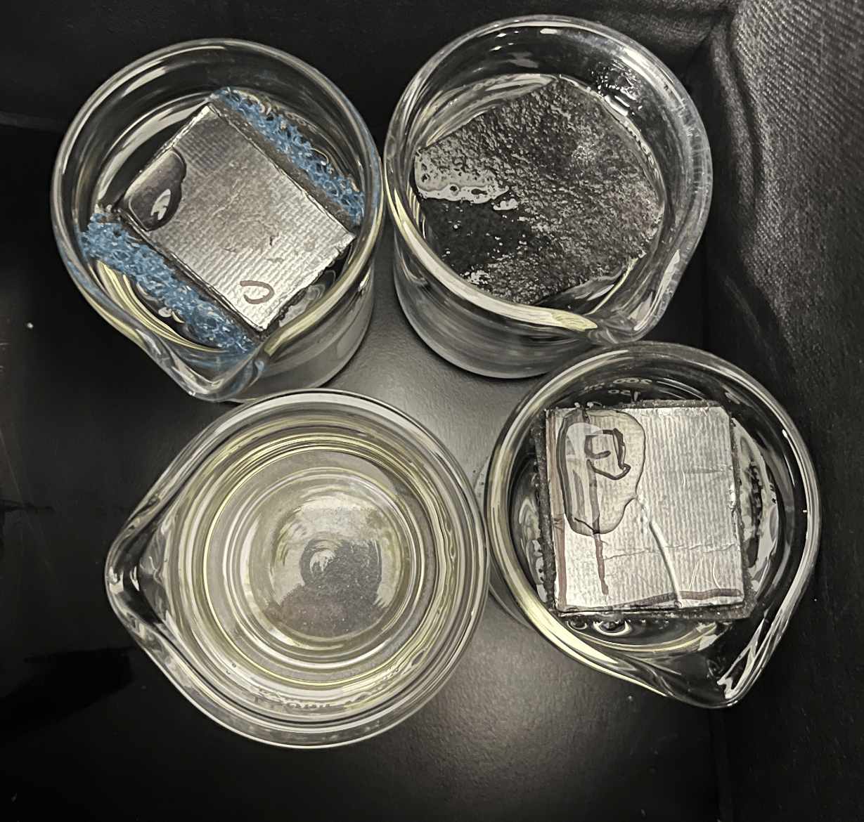
Figure 2: Reduced-scale NaCl trial setup. Four 250 mL beakers of synthetic NaCl brine are shown, three containing reduced-size ISE devices based on the original architectures.

After each run was completed, recorded temperature and relative humidity data were compiled to assess environmental consistency during testing. Measured brine-volume data were then used to calculate run-averaged volumetric evaporation rates before conversion to estimated water-mass evaporation rates.
As concentrated brine density differs from that of pure water, the initial approximation of 1mL brine-volume loss = 1g water loss was evaluated retrospectively using a concentration-dependent mass-balance model. For MgCl₂ and LiCl where no visible precipitation occurred, dissolved salt was assumed to remain constant throughout evaporation. Concentration-dependent solution densities were obtained from published literature data and incorporated into the mass-balance model to estimate remaining water mass from measured brine volume and conserved salt mass [14, 16].
For NaCl, concentration-dependent solution-density data were used to model increasing concentration until saturation was reached [15]. After saturation, further water loss was assumed to precipitate the excess NaCl required to maintain the liquid phase near saturation.
Since NaCl precipitation could affect graduated-beaker readings through displacement of brine by submerged crystals, an additional sensitivity calculation was performed. The primary correction assumed that the recorded volume represented predominantly liquid brine. As a conservative alternative case, all precipitated NaCl was assumed to remain submerged and thus contribute its solid volume to the measured level.
$$V_{liquid}=V_{measured}-V_{precipitate}$$
$$V_{precipitate}=\frac{m_{NaCl precipitant}}{ρ_{NaCl(s)}}$$
This precipitated salt mass was estimated from the salt mass balance, and solid volume was calculated from the density of crystalline NaCl [17]. This solid volume was then subtracted from the measured volume before determining the remaining water mass. Across the NaCl experiments, this limiting assumption shifted the correction relative to the original 1mL = 1g approximation to approximately +1.5% to +3%, compared with approximately -7% to -10% under the liquid-volume assumption. The resulting range was thus treated as a conservative sensitivity range rather than an uncertainty. All resulting correction ranges are summarized below in Table 6.
Brine | Initial wt% | Visible Precipitation? | Correction to original volume-derived rate
MgCl₂ | 14.7% | No | +0.54 to +0.88%
NaCl | 23.7% | Yes | −6.95 to −10.28%
LiCl | 34.8% | No | +0.54 to +0.95%
Table 6: Estimated systematic correction to evaporation rate resulting from concentration-dependent brine density and NaCl precipitation. Positive values indicate the original 1mL = 1g approximation underestimated water loss, and vice versa. NaCl estimates assume recorded volume primarily represents liquid-brine volume. Additional solid-displacement sensitivity analysis produced an approximate upper sensitivity bound of approximately +3%.
These volume-derived rates were then converted to model-corrected water evaporation rates (g H₂O/day) using the concentration-dependent density and mass-balance procedure described above. The reconstructed water-loss values were divided by elapsed experimental time to obtain the model-corrected water evaporation rate
$$R_{m}=\frac{∆m_{H_{2}O}}{∆t}$$
Where R_{m} is expressed in g H₂O/day. Area normalized evaporation efficiency was then calculated as
$$E_{a}=\frac{R_{m}}{A}$$
Where A is the exposed photothermal area of the device, giving units of g H₂O/day/cm². Material cost efficiency was calculated as
$$E_{c}=\frac{R_{m}}{C}$$
Where C is the estimated material cost of each individual device, yielding units of g H₂O/day/$.
Structural failure was defined as loss of functional exposure of the photothermal surface, including substantial coverage by precipitated salt or device sinking that prevented effective exposure to illumination. Visible material degradation or corrosion was recorded separately unless it directly resulted in loss of functional photothermal exposure. Device material cost was estimated from the purchase price of each component and the estimated fraction of material incorporated into each device. It should be noted that the reduced-scale follow-up experiments utilized significantly smaller evaporator devices, resulting in a much lower estimated cost. Estimated material costs for each device and each trial are reported below in Table 7.
Trial | A cost ($) | B cost ($) | C cost ($)
MgCl₂ Trial 1 | 20 | 7 | 6
MgCl₂ Trial 2 | 9.12 | 4.96 | 7.25
NaCl Trial 1 | 20 | 5.68 | 5.05
NaCl Trial 2 | 9.12 | 2.70 | 3.93
LiCl Trial 1 | 20 | 3.60 | 5.05
LiCl Trial 2 | 9.12 | 1.71 | 2.50
Table 7: Estimated material cost of Structures A, B, and C for each experimental trial.

Results
Three interfacial solar evaporator designs were evaluated using MgCl₂, NaCl, and LiCl brines under elevated-temperature, low-humidity laboratory conditions. Each design was assessed using area-normalized evaporation rate (g H₂O day⁻¹cm⁻²), cost-normalized performance (g H₂O day⁻¹$⁻¹), and qualitative observations of material integrity and functional behavior. Six total trials were conducted: one original-scale trial and one reduced-scale follow-up trial for each of the three brines.
Across all six trials, relative performance depended on both the tested brine condition and the evaluation metric. In both MgCl₂ configurations, Structure A achieved the highest area-normalized evaporation rate while Structure B was the lowest. In NaCl, Structures A and B switched ranking between the original-scale and reduced-scale configurations. Thus, no consistent A-B ordering was observed. In both LiCl conditions, Structure B achieved the highest area-normalized evaporation rate. Cost-normalized rankings differed. Structure C ranked highest in both MgCl₂ trials, while Structure B ranked highest in both NaCl and LiCl trials. Structure A maintained the greatest whole-device water removal within each brine condition and showed no comparable visible material deterioration although NaCl accumulation caused functional failure. These results demonstrate condition- and metric- dependent performance. Area and cost normalized performances across all six trials are summarized in Figure 3.
Area-normalized evaporation rate (gH₂O / day / cm²) | Structure A | Structure B | Structure C
MgCl₂ Run 1 | 0.511 ± 0.005 (1) | 0.266 ± 0.004 (0.520) | 0.460 ± 0.005 (0.899)
MgCl₂ Reduced-scale | 0.288 ± 0.018 (1) | 0.134 ± 0.019 (0.466) | 0.217 ± 0.015 (0.752)
NaCl Run 1 | 0.358 ± 0.005 (0.968) | 0.370 ± 0.006 (1) | 0.274 ± 0.006 (0.741)
NaCl Reduced-scale | 0.356 ± 0.007 (1) | 0.316 ± 0.007 (0.887) | 0.265 ± 0.006 (0.745)
LiCl Run 1 | 0.039 ± 0.002 (0.607) | 0.065 ± 0.003 (1) | 0.052 ± 0.002 (0.793)
LiCl Reduced-scale | 0.096 ± 0.004 (0.692) | 0.139 ± 0.007 (1) | 0.128 ± 0.007 (0.925)
Table 8: Absolute and normalized area-normalized evaporation rates of the tested ISE designs. Absolute model-corrected evaporation rates are reported in g H₂O day⁻¹ cm⁻² as value ± propagated volumetric measurement uncertainty. Values in parentheses indicate performance normalized to the highest-performing design within each run.
Cost Efficiency Metric Across Runs | Structure A | Structure B | Structure C
MgCl₂ Run 1 | 1.278 ± 0.012 (0.351) | 2.109 ± 0.034 (0.579) | 3.640 ± 0.040 (1.000)
MgCl₂ Reduced-scale | 0.759 ± 0.048 (0.875) | 0.633 ± 0.089 (0.730) | 0.868 ± 0.061 (1.000)
NaCl Run 1 | 0.896 ± 0.013 (0.305) | 2.931 ± 0.044 (1.000) | 2.172 ± 0.050 (0.741)
NaCl Reduced-scale | 0.936 ± 0.019 (0.375) | 2.500 ± 0.063 (1.000) | 1.669 ± 0.043 (0.668)
LiCl Run 1 | 0.099 ± 0.005 (0.192) | 0.514 ± 0.025 (1.000) | 0.390 ± 0.018 (0.759)
LiCl Reduced-scale | 0.252 ± 0.011 (0.231) | 1.094 ± 0.058 (1.000) | 0.692 ± 0.040 (0.633)
Table 9: Absolute and normalized cost-normalized performance of the tested ISE designs. Absolute model-corrected cost-normalized values are reported in g H₂O day⁻¹ $⁻¹ as value ± propagated volumetric measurement uncertainty. Values in parentheses represent performance normalized to the highest-performing design within each run.
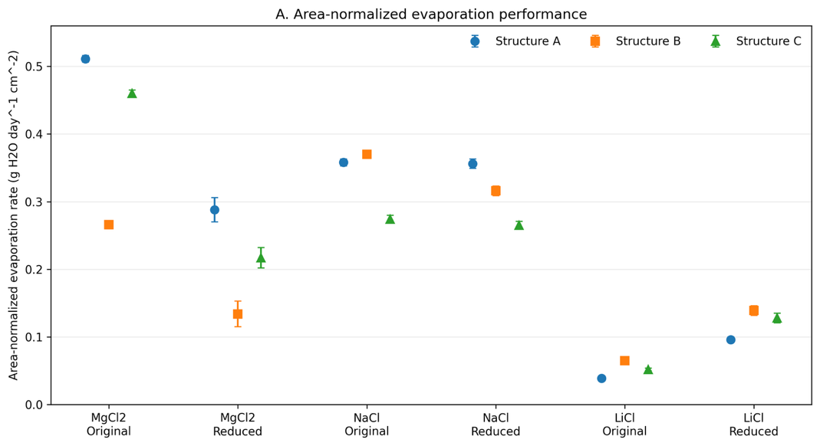
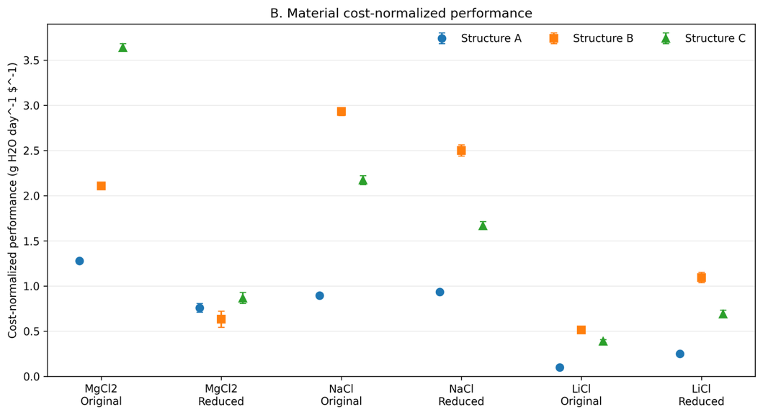
Figure 3. Model-corrected performance of Structures A through C across the six experimental trials. (A) Area-normalized evaporation rate and (B) material cost-normalized performance. Points represent run-averaged values, and error bars represent propagated volumetric measurement uncertainty. Original-scale and reduced-scale follow-up trials are shown separately; error bars do not represent between-device standard deviation, and no inferential statistical comparisons were performed because each design was represented by one physical device per trial.
The following sections examine the performance of each architecture within individual MgCl₂, NaCl, and LiCl brine systems.
MgCl₂ was selected because magnesium-rich brines are widely encountered in critical mineral extraction. Original-scale and reduced-scale trials were conducted to evaluate evaporation performance, cost efficiency, and structural stability across the three ISE designs.
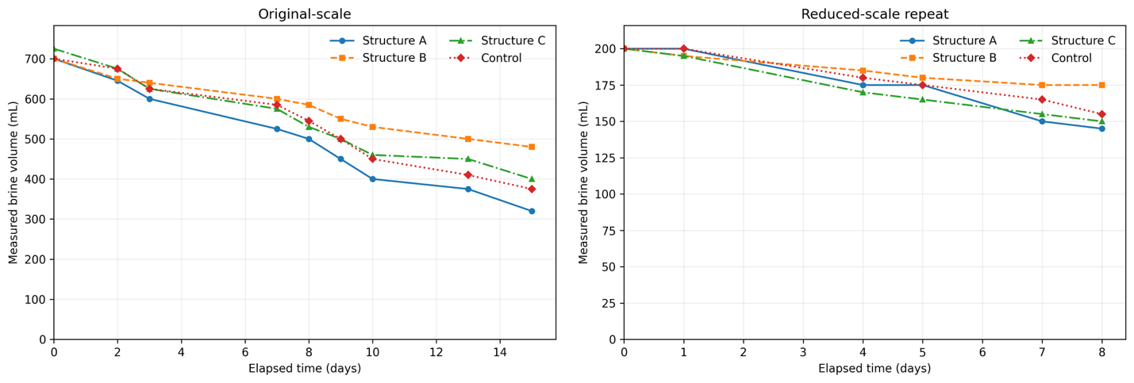
Figure 4. Measured brine volume as a function of elapsed experimental time for Structures A–C and the control during the original-scale (left) and reduced-scale follow-up (right) MgCl₂ trials. Markers indicate individual volume measurements; connecting lines are included only as guides to the eye.
Structure A achieved the highest area-normalized evaporation rate in both MgCl₂ trials (Table 8). In the original-scale trial, Structure A achieved 0.511 ± 0.005 g H₂O day⁻¹cm⁻², compared with 0.460 ± 0.005 for Structure C and 0.266 ± 0.004 g H₂O day⁻¹cm⁻² for Structure B. In the reduced-scale follow-up trial, the same qualitative ranking occurred: Structure A achieved 0.288 ± 0.018 g H₂O day⁻¹cm⁻², Structure C achieved 0.217 ± 0.015 g H₂O day⁻¹cm⁻², and Structure B achieved 0.134 ± 0.019 g H₂O day⁻¹cm⁻². Structure C nevertheless achieved the highest cost-normalized performance in both trials because of its lower estimated material cost (Table 9). Time-resolved brine-volume trends are shown in Figure 4, while representative post-trial device condition is shown in Figure 5.
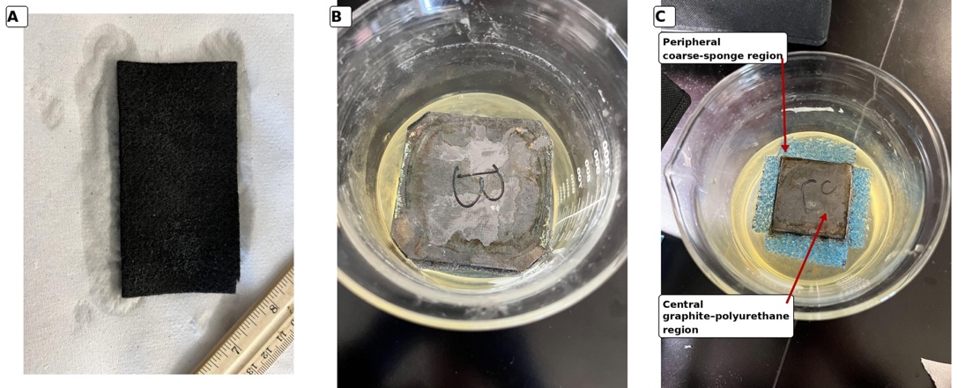
Figure 5: Structures A (left), B (middle), and C (right) during the first MgCl₂ trial. Structure A is shown after removal from the brine, whereas Structures B and C are shown immersed in their respective brines. Photographs document qualitative material condition rather than matched endpoints. No visible salt accumulation occurred on any of the three devices. Structure A retained visible material integrity, whereas Structures B and C exhibited visible surface discoloration/degradation. In Structure C, annotations identify the central graphite–polyurethane photothermal region and the peripheral coarse-sponge region incorporated for the intended salt-management function.

None of the three structures exhibited salt accumulation. Structure A had no comparable visible material degradation. Structures B and C developed brown degradation products on the photothermal layer and the brine itself, although structural failure was not observed.
NaCl was selected because sodium-rich brines are extremely common. Original and reduced-scale trials were conducted to evaluate evaporation performance, cost efficiency, and structural stability across the three ISE architectures. Time-resolved NaCl volume measurements are shown in Figure 6.
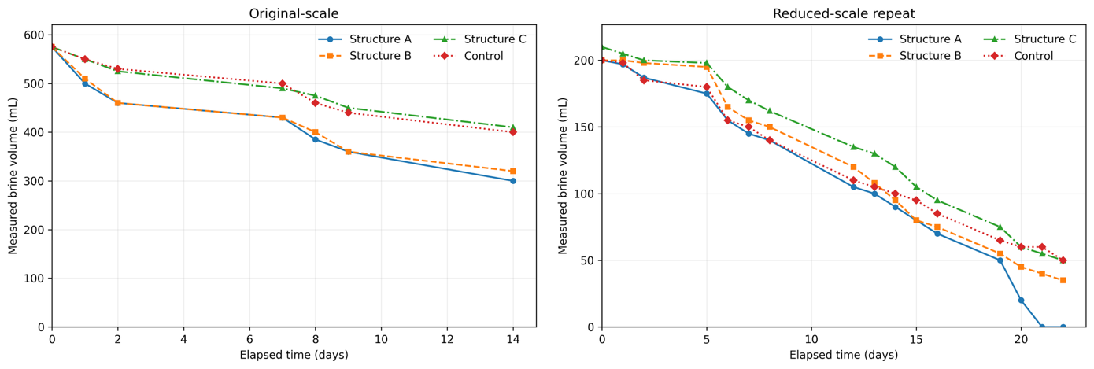
Figure 6: Measured brine volume as a function of elapsed experimental time for Structures A–C and the control during the original-scale (left) and reduced-scale follow-up (right) NaCl trials. Markers indicate individual volume measurements; connecting lines are included only as guides to the eye.

Structures A and B demonstrated similar but run-dependent evaporation performance in NaCl brine. In the first trial, Structure B produced the highest area-normalized evaporation rate (0.370 ± 0.006 g H₂O day⁻¹cm⁻²), narrowly exceeding Structure A (0.358 ± 0.005 g H₂O day⁻¹cm⁻²). In the second trial, the ranking reversed, with Structure A achieving the highest area-normalized evaporation rate (0.356 ± 0.007 g H₂O day⁻¹cm⁻²) compared with Structure B (0.316 ± 0.007 g H₂O day⁻¹cm⁻²). Structure C exhibited the lowest area-normalized evaporation rate in both trials. Structure B nevertheless achieved the highest cost efficiency in both NaCl experiments because of its lower material cost. These results indicate comparable performance between Structures A and B under NaCl conditions rather than a consistently superior architecture.
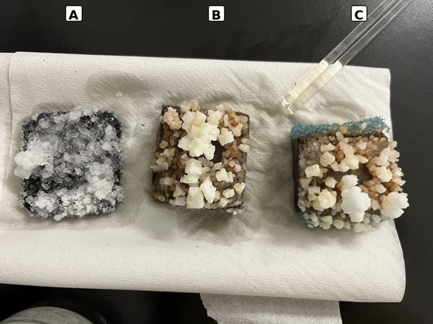
Figure 7: Structures A (left), B (middle), and C (right) at the end of the reduced-scale NaCl trial. Heavy salt accumulation on Structure C partially obscures the boundary between its central photothermal and peripheral coarse-sponge regions.
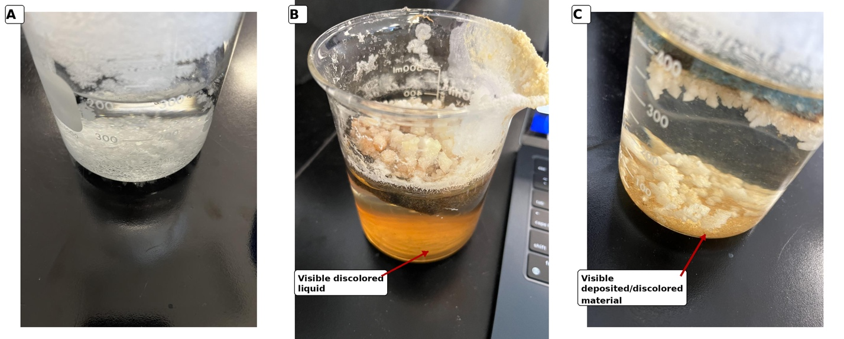
Figure 8: Brines containing Structures A (left), B (middle), and C (right) at the end of the original-scale NaCl trial (day 14; February 25, 2026). All three devices are submerged. All three devices experienced substantial salt accumulation during testing. Annotations identify visible liquid discoloration associated with Structure B and visible deposited/discolored material associated with Structure C. The chemical composition of the observed material was not determined.

All three structures exhibited significant salt accumulation causing structural failure. Structure A had no comparable visible material degradation. Structures B and C developed brown degradation products on the photothermal layer, precipitants, and the brine itself. End-of-trial device and brine conditions are shown in Figures 7 and 8, respectively.
LiCl was selected as a model lithium-bearing brine relevant to lithium concentration. Original and reduced-scale trials were conducted to evaluate evaporation performance, cost efficiency, and structural stability across the three ISE architectures. Time-resolved LiCl volume measurements are shown in Figure 9.
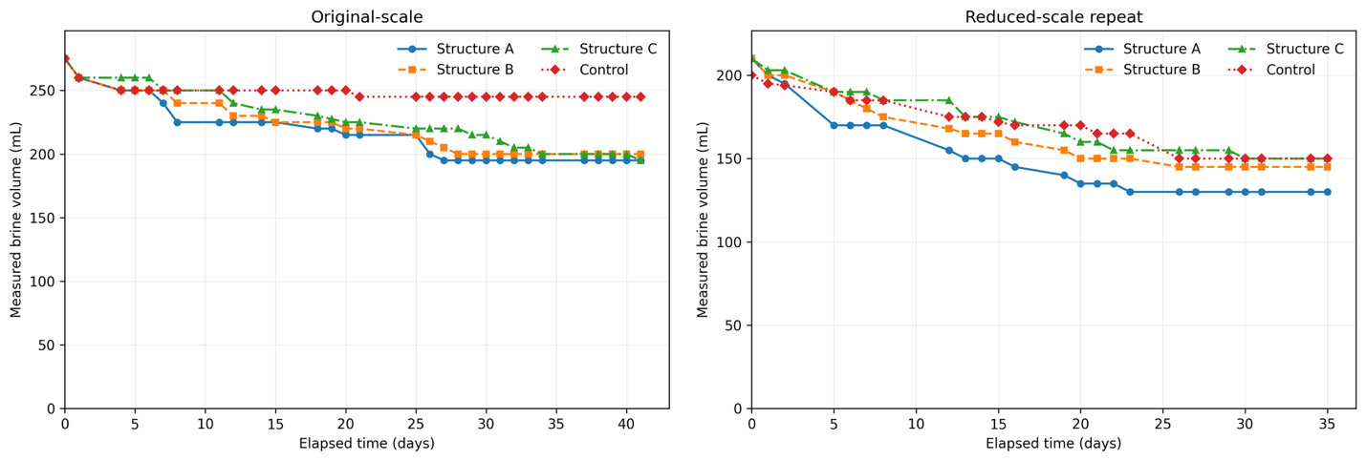
Figure 9: Measured brine volume as a function of elapsed experimental time for Structures A through C and the control during the original-scale (left) and reduced-scale follow-up (right) LiCl trials. Markers indicate individual volume measurements; connecting lines are included only as guides to the eye.

Structure B produced the highest model-corrected area-normalized evaporation-efficiency point estimate in both LiCl trials and also achieved the highest cost efficiency (Tables 8 and 9). Structure A produced the greatest total evaporation volume within each LiCl trial but had the lowest area- and cost-normalized performance. Structure C exhibited intermediate area-normalized performance. The qualitative evaporation-efficiency ranking (B > C > A) occurred in both LiCl trials. However, due to limited number of independently fabricated devices and differing airflow characteristics, the repeated rankings should be interpreted as a recurring pattern rather than statistical evidence of reproducibility.
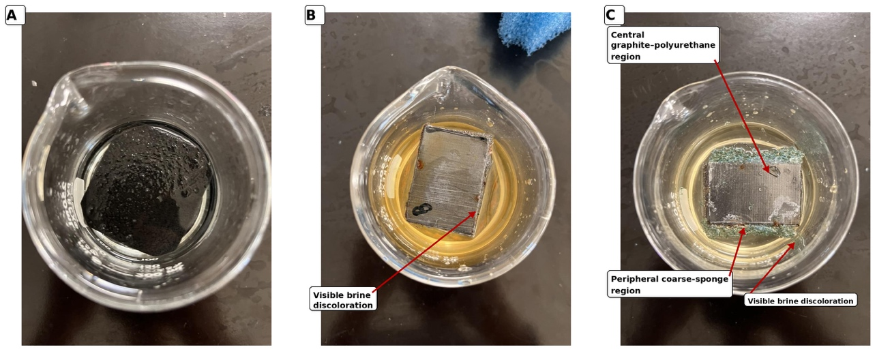
Figure 10: Brines and ISE Structures A (left), B (middle), and C (right) photographed at the end of the reduced-scale LiCl follow-up trial (June 5, 2026) on the day of the final volume measurement. Photograph taken while all 3 structures are immersed. No visible salt precipitation or salt-induced structural failure was observed. Structure A showed no comparable visible material degradation, whereas Structures B and C exhibited visible material changes and brine discoloration. Annotations identify visible brine discoloration and, for Structure C, the central graphite–polyurethane and peripheral coarse-sponge regions. The composition of the discolored material was not chemically characterized.

Structures B and C exhibited visible material degradation, while no salt precipitation or structural failure was observed. Structure A showed no comparable visible material degradation. Brown carbonaceous products developed on the photothermal layers of Structures B and C and were also observed in the brine. Representative post-trial device/brine conditions are shown in Figure 10.

Discussion

Performance Trade-offs Among Tested Material–Architecture Designs
No single tested design demonstrated universally superior performance across the tested brine conditions and evaluation metrics. Structures A, B, and C differed in device geometry, layer composition, brine contact configuration, photothermal material, and more. Thus, the present experiments compare specific material-architecture combinations rather than isolating architecture as an independent variable. The rankings reported apply to the tested devices and brine configurations rather than to all carbon-felt, Janus, and directional-crystallization architectures in MgCl₂, NaCl, and LiCl brine systems.
Among the three structures, the Janus design (Structure B) demonstrated several potential advantages. The graphite-polyurethane arrangement was designed to separate the upper photothermal region from the bulk brine while supplying liquid through capillary transport [9, 19]. Such separation can theoretically reduce direct thermal coupling to the bulk solution and maintain heat near the evaporation interface. While thermal localization is an intended benefit of the Janus configuration, its contribution to the observed performance could not be isolated because interfacial temperature and heat-transfer losses were not measured. The dual-layer architecture also provides opportunities for future material optimization because the photothermal and liquid-transport components can be modified independently.
Structure B did not fully prevent fouling or material degradation. Brown carbonaceous degradation products were observed across tested brines, while substantial salt precipitation occurred during NaCl experiments. Potential contributors include surface wetting, repeated electrolyte exposure, mechanical delamination, or chemical alteration. The present study did not chemically characterize the degradation pathway. Consequently, the exact mechanism of producing the observed deposits cannot be determined.
Structure A maintained direct contact with the bulk brine and provided a large porous photothermal surface. Concentration-gradient-driven back-diffusion was an intended salt-management mechanism of the design, but ion transport was not directly measured. Moreover, the absence of visible salt accumulation in the MgCl₂ and LiCl trials did not distinguish Structure A from the other tested designs because no visible precipitation occurred on any architecture under those conditions. During NaCl testing, all three designs eventually experienced substantial crystallization. The present results therefore do not independently establish enhanced salt rejection by Structure A, although its porous direct-contact configuration remains a design rationale for future controlled testing.
Structure C was designed to redistribute liquid supply and salt crystallization between a fine-pore central polyurethane region and coarser peripheral sponge regions. Differences in characteristic pore size can alter capillary pressure and liquid transport, and directional-crystallization designs have been investigated as a strategy for relocating salt accumulation away from active evaporation surfaces [13,21]. However, this relationship alone does not establish a net directional pathway toward the peripheral sponge. Additionally, pore-size distributions, local flow rates, and crystallization location as a function of time were not directly measured, so directional transport remains an intended design mechanism rather than a demonstrated outcome.
During NaCl testing, substantial crystallization occurred on the central photothermal region, demonstrating that complete exclusion of salt from the absorber was not achieved. This observation does not determine whether the peripheral regions altered the timing or spatial distribution of crystallization relative to a device without those regions. The peripheral sponge also occupied part of the total device footprint. Because area-normalized evaporation was calculated using the central photothermal area, this reduction in absorber area does not by itself explain a lower per-unit-area evaporation rate; instead, it represents a footprint-level trade-off in which part of the device area is allocated to salt management rather than photothermal evaporation.

Salt Fouling and Material Degradation
Two material-performance concerns were observed during testing: salt-induced functional failure and visible degradation of the photothermal material. Salt accumulation was most severe during both NaCl trials, where crystallization progressively covered the photothermal surfaces and contributed to device sinking. Naturally occurring brine ponds generally have Na⁺ concentrations exceeding 100g/L and Mg²⁺ concentrations exceeding 15g/L, while Li⁺ concentrations remain limited under 1g/L [18]. Periodic removal or redissolution of deposited salts could mitigate fouling, but such maintenance would introduce additional operational complexity and cost at larger scale.
Visible degradation was observed in the graphite-containing Structures B and C, producing brown carbonaceous material on the photothermal surface and within the brine. Because the degradation products were not chemically characterized, their precise composition cannot be determined from visual observation alone. The observed changes are consistent with graphite oxidation, exfoliation, mechanical delamination, or a combination of these processes. Structure A exhibited no comparable visible degradation.
The observed degradation raises two practical concerns. First, loss or delamination of the graphite photothermal layer could progressively alter device performance and ultimately reduce operational lifetime. The present experiments did not quantify the relationship between degradation and photothermal efficiency, and future work should therefore combine long-duration evaporation testing with surface-temperature measurements and material characterization. Raman spectroscopy, FTIR, or XPS could distinguish oxidation from mechanical exfoliation and determine whether oxidized graphite species are present.
Second, degradation of the graphite layer introduced visible carbonaceous material into the processed brine. Brown-to-dark suspended material and sludge-like deposits were observed in trials involving Structures B and C. Because the material was not chemically characterized, it cannot be determined whether these deposits consisted primarily of mechanically exfoliated graphite, oxidized graphite products, or other carbonaceous fragments. Regardless of composition, release of photothermal material into the brine represents a potential contamination concern for downstream mineral recovery.
Such particulate contamination could plausibly interfere with downstream filtration, adsorption, membrane separation, or other purification processes through fouling or accumulation on processing surfaces. However, the amount and composition of released material were not quantified in this study, so its effect on downstream lithium recovery remains hypothetical. Future studies should filter post-test brine through pre-weighed membranes to quantify released solids and use Raman spectroscopy, FTIR, XPS, SEM/EDS, or related techniques to characterize the degradation products.
Visible degradation occurred only in Structures B and C, both of which contained graphite. Visible delamination of the graphite sheet and release of carbonaceous material indicates material degradation under the tested conditions. A representative example of visible graphite-layer delamination is shown in Figure 11. However, the relative contributions of chemical oxidation, electrolyte-assisted changes, mechanical delamination, and repeated wetting/drying could not be distinguished without material characterization. These observations indicate limited visible stability of the graphite material under the tested conditions and motivate investigation of more durable photothermal materials. Additional characterization is required to determine the degradation pathway.
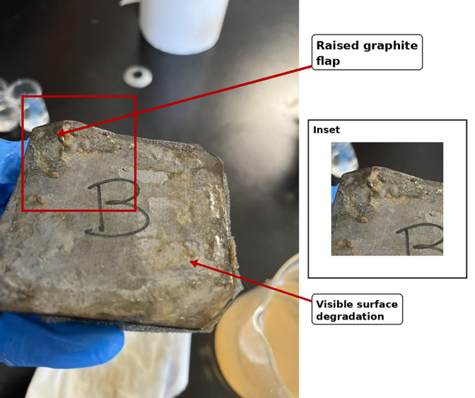
Figure 11: Structure B following the first MgCl₂ trial, showing visible degradation of the graphite-containing surface. The arrow identifies a visibly raised graphite flap in the upper-left portion of the device, and the inset provides an enlarged view of this feature. A second annotation identifies visible surface degradation elsewhere on the photothermal layer. The image documents physical changes to the device but does not establish the chemical mechanism of degradation.

Carbon felt retained visible material integrity during the tested runs. This did not, however, prevent salt precipitation and subsequent functional failure during NaCl testing, demonstrating that material integrity and fouling resistance are distinct device properties.

Area-normalized Evaporation Rate vs. Cost-Normalized Performance for Practical Applications
Area-normalized evaporation and cost-normalized performance represent complementary engineering metrics rather than independent measures of the physical evaporation mechanism. Both use the same reconstructed water-removal rate as their numerator.
$$R_{A}=\frac{R}{S}$$
represents area-normalized evaporation rate (R_{A}), where R is the corrected evaporation rate and S is the estimated exposed photothermal area.
$$R_{C}=\frac{R}{C}$$
represents cost-normalized performance (R_{C}), where R is the corrected evaporation rate and C is estimated material cost. Both R_{A} and R_{C} vary based on the model-corrected evaporation rate. With these two relationships, we conclude that
$$R_{C}=R_{A} \frac{S}{C}$$
A design can therefore improve its cost-efficiency ranking through inexpensive construction or a favorable area-to-cost ratio even without producing a higher evaporation flux. Accordingly, the strong cost efficiency of Structures B or C should not be interpreted as additional evidence for superior thermal localization or capillary transport.
In the tested MgCl₂ configurations, for example, Structure C's low material cost produced the highest cost-normalized performance despite Structure A producing the highest area-normalized evaporation rate. Conversely, Structure B combined relatively low estimated material cost with strong normalized performance in the tested NaCl and LiCl configurations.
The preferred metric depends on the dominant engineering constraint. If available evaporative area is limiting, area-normalized performance becomes especially important -- Structure A ranked highest under MgCl₂ conditions, while Structure B ranked highest in LiCl conditions. If material cost is more restrictive, the relatively inexpensive graphite-based architectures may appear advantageous. However, material degradation introduces additional considerations that are not captured by purchase-price cost efficiency alone.
The release of carbonaceous material from Structures B and C raises potential maintenance and downstream-purity concerns. A carbon-felt/Janus configuration therefore represents a candidate for future testing. However, replacing graphite with carbon felt would also alter liquid contact, geometry, thermal transport, and potentially capillary behavior relative to Structures A and B. The proposed hybrid should therefore be evaluated as a new material–architecture design rather than assumed to retain independently the advantages observed for either structure.

MgCl₂ Trials – Analysis of Structure B Performance
Structure B exhibited the lowest area-normalized evaporation rate in both tested MgCl₂ configurations but the highest in both tested LiCl configurations. Because device dimensions, experimental scale, and environmental conditions were not identical across the brine systems, this contrast cannot be attributed solely to solution chemistry. Nevertheless, the result motivates consideration of how thermodynamic evaporation potential and capillary liquid supply might interact within the graphite–polyurethane design.
One possible framework is the balance between potential interfacial evaporative demand and capillary replenishment. Structure B relies on polyurethane foam to supply liquid to the graphite evaporation surface. If liquid removal at the interface exceeds the rate at which the porous layer can replenish it, localized depletion or partial drying could reduce effective evaporation [19]. This framework is presented here as a physically plausible interpretation rather than a demonstrated operating regime because surface wetness and capillary flow rates were not measured.
The MgCl₂ and LiCl solutions differed substantially in thermodynamic properties. For instance, there is a significant difference in water activity. Water activity (a_{w}) is a measure of effective thermodynamic availability of water, generally related to the ratio of the equilibrium vapor pressure to that of pure water at the same temperature. The tested LiCl solutions began at approximately 10.0 M, with literature-derived initial water activities near 0.29–0.30, whereas the tested MgCl₂ solutions began near 1.74 M with estimated initial water activities near 0.86–0.88. Lower a_{w} corresponds to lower equilibrium water-vapor pressure and therefore a reduced thermodynamic driving force for evaporation. At the same time, high electrolyte concentration can increase viscosity and resist liquid transport [16, 20]. These opposing effects make absolute viscosity alone insufficient to predict whether a porous supply layer will constrain performance.
Capillary penetration through a porous material can be examined qualitatively using the Washburn relationship [21]:
$$L^{2}=\frac{γRtcosθ}{4η}$$
Where L is penetration distance, $γ$ is liquid surface tension, R is effective pore radius, $θ$ is contact angle, $η$ is dynamic viscosity, and t is time. The Washburn relationship was not used for quantitative prediction because effective pore radius, contact angle, and other required transport parameters were not measured. It is included only as a qualitative framework illustrating how viscosity, pore geometry, surface tension, and wettability can influence capillary replenishment.
As polyurethane foam contains a heterogeneous interconnected pore network rather than ideal cylindrical capillaries, this relationship is used only as an approximate physical framework. Changes in viscosity, surface tension, wettability, geometry, and immersion depth could all affect liquid delivery.
The architecture of Structures B and C makes them more susceptible to such transport limitations than Structure A. Both graphite–polyurethane devices depend on porous liquid transport to maintain the evaporation interface, whereas Structure A remains in more direct contact with the bulk solution.
However, the present dataset cannot determine whether Structure B was transport-limited in MgCl₂ or whether liquid supply was adequate in LiCl. The contrasting rankings are merely compatible with a supply–demand interpretation. Direct measurements of capillary uptake, surface wetness, contact angle, interfacial temperature, viscosity, and immersion geometry under otherwise matched conditions would be required to test this hypothesis.
Differences in device geometry and buoyancy may also have contributed to the observed performance. Because Structure B depends on buoyant polyurethane foam to position the graphite layer at the liquid–air interface, changes in brine density could alter device immersion depth and therefore the distance or pathway over which liquid must be transported. Device dimensions also differed among experimental scales and brine conditions, meaning that area normalization does not necessarily account for differences in capillary transport distance, perimeter-to-area ratio, or surface wetting. These factors were not directly measured and therefore represent possible experimental contributors rather than demonstrated mechanisms.
The relatively low initial concentration of the MgCl₂ brine may additionally have reduced the practical benefit of the Janus architecture. No visible salt accumulation occurred during either MgCl₂ trial, meaning that physical separation of the graphite surface from the bulk solution did not provide an observable anti-fouling advantage during the experimental period. At the same time, the architecture retained the potential resistance associated with transporting liquid through polyurethane foam. Under more concentrated NaCl conditions, where substantial crystallization occurred, physical separation and controlled liquid transport may offer greater functional value. The LiCl comparison is more complex because little precipitation occurred despite its high concentration, further suggesting that precipitation resistance alone cannot explain Structure B's relative performance.

LiCl Trials – Commercial Relevance and High-Concentration Evaporation
Under the tested configurations, the LiCl experiments produced the lowest area-normalized evaporation rates and the lowest whole-device water removal among the three brine systems. Because environmental conditions differed among brine systems, this cross-brine difference cannot be assigned solely to LiCl chemistry. Nevertheless, the high initial LiCl concentration provides relevant thermodynamic context. Literature-derived initial water-activity estimates were approximately 0.29–0.30, substantially lower than those of the tested MgCl₂ solutions (Table 10).
LiCl remained visibly dissolved throughout testing, unlike NaCl, which underwent substantial crystallization. Continued water removal was therefore modeled as increasing dissolved LiCl concentration. The resulting final molalities and water activities in Table 10 are reconstructed/model-derived quantities based on the same volume-loss measurements used to calculate evaporation and on published property relationships. Their decline therefore provides a thermodynamic interpretation of the experiment rather than independent experimental confirmation that reduced water activity caused the observed rate decline.
Increasing LiCl concentration may also increase viscosity and density and could promote concentration gradients near the evaporation interface. However, local concentration, viscosity, and velocity fields were not measured, so concentration polarization and transport limitation cannot be confirmed from the present dataset. Controlled LiCl concentration-series experiments with direct measurement of these properties would be required to isolate their contributions.
Trial | Initial molality | Initial a_{w} | Final molality | Final a_{w}
MgCl₂ Run 1 | 1.75-1.82 | 0.868-0.875 | 2.86-4.42 | 0.523-0.742
MgCl₂ Reduced-scale | 1.925 | 0.857 | 2.21-2.71 | 0.761-0.824
NaCl Run 1 | 5.31 | 0.793 | 6.1 | 0.756
NaCl Reduced-scale | 5.225 | 0.797 | 6.1 | 0.756
LiCl Run 1 | 12.58-12.82 | 0.286-0.296 | 20.78-21.02 | 0.093-0.095
LiCl Reduced-scale | 12.59 | 0.296 | 18.5-24.4 | 0.062-0.128
Table 10: Estimated initial and final brine molalities and corresponding literature-derived water activities (a_{w}). Initial molalities were calculated from salt-preparation recipes. Final molalities were reconstructed from measured volume change, salt-mass conservation, and concentration-dependent density data [14–16]. Water activities were estimated from published thermodynamic data for MgCl₂ and NaCl [22] and concentrated-LiCl property correlations [16]. Values represent literature-derived estimates near 25 °C rather than direct experimental measurements.
In all, the LiCl experiments indicate that ISE performance may become increasingly constrained as lithium brines become highly concentrated. Future work should therefore evaluate evaporation across controlled LiCl concentration gradients while directly measuring water activity, viscosity, surface temperature, and capillary replenishment under standard illumination and airflow.

Limitations in Experimental Design
Several experimental limitations should be considered when interpreting the results.
First, only one physical ISE device of each architecture was evaluated within each experimental trial. The reduced-scale follow-up experiments therefore assessed whether broad architecture-performance patterns recurred under a modified experimental configuration, but they did not independently quantify device-to-device fabrication variability. Future studies should test multiple independently fabricated devices of each architecture simultaneously and repeat those experiments to enable statistical evaluation of reproducibility.
Device geometry also varied across architectures and experimental scales. Structure A was positioned differently in some experiments, with earlier devices maintaining a partially elevated or folded evaporation region while later reduced-scale devices were flatter. Although evaporation performance was normalized using measured projected photothermal area, differences in three-dimensional geometry could have altered effective evaporative area, liquid contact, heat transfer, and salt transport. Similarly, differences in device dimensions may have influenced capillary transport distance and immersion behavior in Structures B and C. Future testing should standardize projected area, thickness, geometry, and immersion depth wherever possible.
The synthetic brines used in this study contained individual salts rather than the mixed ionic compositions encountered in natural or industrial brines. Consequently, precipitation sequence, ionic interactions, viscosity, water activity, and competitive transport behavior were simplified. The design rankings observed here therefore should not be assumed to reproduce those of natural lithium- or magnesium-bearing brines without additional mixed-brine testing.
Evaporation was estimated from graduated-beaker volume measurements rather than direct gravimetric mass loss. The 5 mL graduations corresponded to an estimated individual reading uncertainty of ±2.5 mL and were insufficient to reliably resolve some small day-to-day changes, particularly during the LiCl and reduced-scale trials. Using cumulative volume changes over 8–41 day observation periods reduced the propagated uncertainty in run-averaged volumetric rates to approximately 0.9–14.1%, but gravimetric measurements would provide a more direct and precise determination of water loss.
Concentrated-brine density further complicated conversion from measured volume loss to water-mass loss. Retrospective concentration-dependent mass-balance calculations indicated relatively small corrections for the nonprecipitating MgCl₂ and LiCl experiments, whereas NaCl required additional assumptions because crystallization altered the relationship among measured liquid level, dissolved salt mass, and remaining water. The primary NaCl model produced corrections of approximately −7% to −10%, while a conservative limiting assumption in which precipitated NaCl contributed solid displacement broadened the model-sensitivity range to an upper bound of approximately +3%. This range represents sensitivity to the interpretation of precipitated-solid volume rather than instrumental measurement uncertainty. However, cumulative volume changes over 8–41-day observation periods were substantially larger than the graduation interval, reducing propagated uncertainty in the reported run-averaged rates to approximately 0.9–14.1%.
Environmental conditions were not fully standardized across all experiments. Incident irradiance at the evaporator surface was not directly measured, laboratory scheduling affected heat-lamp operating periods, and forced airflow was used only during the first LiCl experiment. Original-scale experiments also placed experimental groups in separate chambers, whereas reduced-scale follow-up placed all groups within a single chamber. These differences limit quantitative comparison of absolute evaporation rates across brine systems and experimental scales. Consequently, cross-brine comparisons in this study were interpreted primarily as qualitative patterns rather than isolated effects of brine chemistry. Future experiments should directly measure irradiance, standardize lamp-to-sample geometry and exposure duration, maintain identical airflow across all groups, and quantify air velocity.
Repeated device removal for volume measurements may also have introduced small disturbances to retained liquid, accumulated salts, surface wetting, or device orientation despite use of a standardized procedure. Future gravimetric measurements that allow devices to remain in place would reduce this potential source of disturbance.
Reuse of the same carbon felt between the two trials of a given brine condition may have introduced surface-history effects, although cross-brine reuse did not occur.
Finally, the reduced-scale MgCl₂ trial ended before substantial late-stage concentration or precipitation because of laboratory time constraints. Although sufficient data were collected to estimate run-averaged evaporation and cost efficiency, a longer experiment would be required to characterize device behavior as MgCl₂ approaches higher concentrations and potentially different transport regimes.

Future Directions
Future work should first improve experimental control and replication. Incident irradiance should be measured directly at the evaporator surface using a calibrated radiometer or solar power meter, while lamp-to-sample distance, illumination duration, temperature, relative humidity, and airflow should be standardized across all experimental groups. Air velocity should also be quantified. Evaporation should be measured gravimetrically using analytical balances rather than inferred from graduated-beaker volume changes, allowing more precise determination of water loss without repeated device removal.
Experimental replication should also be expanded by testing multiple independently fabricated devices of each architecture under identical conditions. Projected photothermal area, device thickness, immersion depth, starting brine volume, and container geometry should be standardized wherever possible. These changes would allow statistical comparison of the tested designs while separating device-to-device fabrication variability from reproducible design-to-design differences.
Future experiments should also test the transport mechanisms proposed in the present Discussion. Capillary uptake rate, solution viscosity, contact angle, water activity, interfacial temperature, and device immersion depth should be measured directly across controlled brine concentrations. Such measurements could determine whether the reduced relative performance of Structure B under MgCl₂ conditions resulted from an imbalance between capillary replenishment and evaporative demand. Controlled concentration-series experiments using MgCl₂ and LiCl would be particularly useful for separating the effects of viscosity, water activity, and brine composition.
More chemically realistic mixed brines should subsequently be investigated. Natural and industrial brines contain multiple cations and anions whose interactions can alter precipitation sequence, water activity, viscosity, density, and salt transport. Testing mixtures containing Li⁺, Na⁺, Mg²⁺, Cl⁻, SO₄²⁻, and other relevant ions would help determine whether the design rankings observed in the present single-salt systems persist under more realistic conditions.
Finally, future research should investigate alternative photothermal materials and hybrid architectures. Carbon felt exhibited no visible material degradation throughout the present experiments, whereas graphite-containing Structures B and C released visible carbonaceous material into the processed brines. Incorporating carbon felt into a Janus-style architecture could therefore test whether its observed stability can be combined with controlled liquid transport and interfacial heat localization. Long-duration testing should quantify material loss, replacement frequency, and downstream contamination so that lifetime cost can be evaluated rather than initial material cost alone.

Conclusions
This study compared three complete interfacial solar evaporator material-architecture designs: a porous carbon-felt direct-contact design (Structure A), a graphite-polyurethane Janus design (Structure B), and a graphite–polyurethane directional-crystallization design incorporating peripheral coarse sponge (Structure C) -- for evaporation-driven pre-concentration of synthetic MgCl₂, NaCl, and LiCl brines. Performance was evaluated using model-corrected area-normalized evaporation rate, whole-device water removal, material cost-normalized performance, fouling behavior, and visible material integrity.
Relative performance depended on both brine condition and evaluation metric. Structure A achieved the highest area-normalized evaporation rate in both MgCl₂ configurations, whereas Structure B achieved the lowest. Structures A and B showed no consistent ordering between the two NaCl configurations, while Structure B achieved the highest area-normalized rate in both LiCl configurations. Cost-normalized rankings differed from area-normalized rankings: Structure C ranked highest in both MgCl₂ trials, whereas Structure B ranked highest in the NaCl and LiCl trials. Structure A produced the greatest whole-device water removal within each brine condition. For example, in the original-scale MgCl₂ trial, Structure A achieved an area-normalized evaporation rate of 0.511 ± 0.005 g H₂O day⁻¹cm⁻² compared with 0.266 ± 0.004 g H₂O day⁻¹cm⁻² for Structure B, whereas in the original-scale LiCl trial, Structure B achieved 0.065 ± 0.003 g H₂O day⁻¹cm⁻² compared with 0.039 ± 0.002 g H₂O day⁻¹cm⁻² for Structure A.
Material behavior introduced additional trade-offs. Carbon felt retained visible material integrity throughout testing, but substantial NaCl crystallization still caused functional failure, demonstrating that material integrity and fouling resistance are distinct properties. Graphite-containing Structures B and C exhibited visible delamination and released carbonaceous material into the processed brine, although the composition and degradation pathway were not determined. These observations indicate that initial material cost alone is insufficient to evaluate practical device performance.
As Structures A to C differed simultaneously in photothermal material, geometry, supporting layers, and liquid-contact configuration, the observed differences cannot be attributed to architecture alone. Environmental conditions also differed among some brine experiments, limiting causal cross-brine comparisons.
Overall, the tested designs exhibited trade-offs among throughput, area-normalized evaporation, material cost, fouling, and material integrity rather than identifying a universally optimal configuration. A carbon-felt/Janus configuration is therefore a candidate for future investigation but should be evaluated as a new material -- architecture design rather than assumed to combine independently the advantages observed for Structures A and B. Future studies should use independently replicated devices, gravimetric evaporation measurements, controlled and measured irradiance and airflow, direct transport and thermophysical measurements, and chemically realistic mixed brines.

Acknowledgements
I would like to express my sincere gratitude to my research and biology teacher, Ms. Jennifer Smolyn, for her invaluable support throughout this project. Her encouragement, approval of this research, and assistance in overcoming numerous logistical challenges made this work possible. Like countless others, I am deeply appreciative of her dedication to supporting student research and scientific inquiry.

I would also like to thank my mentor, Spencer Koonin, Princeton University & Princeton Critical Minerals, for his guidance and mentorship throughout this project. His willingness to meet regularly, provide thoughtful feedback, and discuss both experimental design and manuscript development greatly strengthened this research. I am especially grateful for his insights during the planning and organization of this paper, as well as providing crucial materials for brine synthesis.

Lastly, I would like to offer my thanks to Ms. Juna Lee, who helped oversee data collection for several days. Her assistance ensured the continuity of the experimental data for analysis while supporting the analysis and preparation of this manuscript. I am sincerely grateful for her time, encouragement, and support throughout this project.

Generative AI disclosure: OpenAI ChatGPT GPT-5.6 Sol was used as an auxiliary tool during manuscript preparation and revision from August – September 2026, primarily for language clarity, structural organization, discussion of methodological limitations, assistance with figure formatting, and presentation of data analysis. ChatGPT was consulted periodically throughout manuscript revision. AI-generated suggestions were reviewed and independently evaluated by the author, and calculations, citations, interpretations, and experimental results were manually verified against the original data and cited literature. ChatGPT was not used to conduct experiments or generate experimental data.

Patrick Song independently conducted the experimental design, device fabrication, data analysis, literature review, figure preparation, and manuscript preparation unless otherwise noted. Ms. Jennifer Smolyn provided school supervision, logistical support, and feedback on the research manuscript. Spencer Koonin provided research mentorship, discussion of experimental design and manuscript organization, and materials for brine preparation. Ms. Juna Lee assisted with data collection during several days when the author was unavailable.

Bibliography
[1]: What Are Critical Minerals and Materials? (2025). Energy.gov. https://www.energy.gov/cmm/what-are-critical-minerals-and-materials

[2]: Kim, Tae-Yoon. (2025, October 23). With new export controls on critical minerals, supply concentration risks become reality – Analysis - IEA. IEA.
https://www.iea.org/commentaries/with-new-export-controls-on-critical-minerals-supply-concentration-risks-become-reality

[3]: Yang, K., Yang, M., Chen, H., Zheng, S., Khandelwal, A., Priestley, R. D., & Ren, Z. J. (2025). Interfacial solar evaporation transforms brine mineral recovery. Science Advances, 11(38). https://doi.org/10.1126/sciadv.adx3242

[4]: Kelly, J. C., Wang, M., Dai, Q., & Winjobi, O. (2021). Energy, greenhouse gas, and water life cycle analysis of lithium carbonate and lithium hydroxide monohydrate from brine and ore resources and their use in lithium ion battery cathodes and lithium ion batteries. Resources, Conservation and Recycling, 174, 105762. https://doi.org/10.1016/j.resconrec.2021.105762

[5]: MIT Climate Portal Writing Team. (2024, February 12). How is lithium mined? Climate.mit.edu. https://climate.mit.edu/ask-mit/how-lithium-mined

[6]: Thomas, J. (2024, January 23). The urgent need to pioneer green magnesium production. Innovation News Network. https://www.innovationnewsnetwork.com/the-urgent-need-to-pioneer-green-magnesium-production/42219/

[7]: Armaghan Ehsani Telgerafchi, Rutherford, M., Espinosa, G. P., McArthur, D., Masse, N., Perrin, B., Tang, Z., & Powell, A. (2023). Magnesium production by molten salt electrolysis with liquid tin cathode and multiple effect distillation. Frontiers in Chemistry, 11. https://doi.org/10.3389/fchem.2023.1192202

[8]: Li, Z., Mercken, J., Li, X., Riaño, S., & Binnemans, K. (2019). Efficient and Sustainable Removal of Magnesium from Brines for Lithium/Magnesium Separation Using Binary Extractants. ACS Sustainable Chemistry & Engineering, 7(23), 19225–19234. https://doi.org/10.1021/acssuschemeng.9b05436

[9]: Chen, C., Kuang, Y., & Hu, L. (2019). Challenges and Opportunities for Solar Evaporation. Joule, 3(3), 683–718. https://doi.org/10.1016/j.joule.2018.12.023
[10]: Haghighat, M., Entezarian, M. M., Salimi, M., & Amidpour, M. (2025). Exploring interfacial solar evaporation heat transfer mechanisms of photothermal solar still systems. Case Studies in Thermal Engineering, 68, 105883. https://doi.org/10.1016/j.csite.2025.105883

[11]: Cubillos, C. F., Aguilar, P., Grágeda, M., & Dorador, C. (2018). Microbial Communities From the World’s Largest Lithium Reserve, Salar de Atacama, Chile: Life at High LiCl Concentrations. Journal of Geophysical Research: Biogeosciences, 123(12), 3668–3681. https://doi.org/10.1029/2018jg004621

[12]: Liu, G., Chen, T., Xu, J., Yao, G., Xie, J., Cheng, Y., Miao, Z., & Wang, K. (2021). Salt-Rejecting Solar Interfacial Evaporation. Cell Reports Physical Science, 2(1), 100310. https://doi.org/10.1016/j.xcrp.2020.100310

[13]: Zhao, D., Ding, M., Lin, T., Duan, Z., Wei, R., Feng, P., Yu, J., Liu, C.-Y., & Li, C. (2024). Gradient Graphene Spiral Sponges for Efficient Solar Evaporation and Zero Liquid Discharge Desalination with Directional Salt Crystallization. Advanced Science, 11(22), 2400310. https://doi.org/10.1002/advs.202400310

[14] Monnin, C. (1987). Densities and apparent molal volumes of aqueous CaCl₂ and MgCl₂ solutions. Journal of Solution Chemistry, 16(12), 1035–1048. https://doi.org/10.1007/BF00652587

[15] Lee, S. H. (2020). Dynamic and Static Properties of Aqueous NaCl Solutions at 25°C as a Function of NaCl Concentration: A Molecular Dynamics Simulation Study. Journal of Chemistry, 2020, 6661196. https://doi.org/10.1155/2020/6661196

[16] Conde, M. R. (2004). Properties of aqueous solutions of lithium and calcium chlorides: Formulations for use in air conditioning equipment design. International Journal of Thermal Sciences, 43(4), 367–382. https://doi.org/10.1016/j.ijthermalsci.2003.09.003

[17] Birnbaum, J., Danby, T., Johnson, T., Rose, M., Kelly-Gorham, K., Lindenmaier, R., & Myers, T. (n.d.). Sample Conditions & Physical Properties: Sodium Chloride. Pacific Northwest National Laboratory/NIST. https://webbook.nist.gov/chemistry/silmarils-solids-hrf-drf/docs/META.MIR.PUR.Sodium-chloride.SLD.SIGMA-ALDRICH.PNNL513133.pdf

[18] Zhang, C., He, N., Meng, X., & Zhao, H. (2025). Advances in lithium and sodium separation techniques for brine lithium extraction processes. Journal of Environmental Chemical Engineering, 13(3), 116471. https://doi.org/10.1016/j.jece.2025.116471

[19] Zhang, L., Xu, Z., Zhao, L., Bhatia, B., Zhong, Y., Gong, S., & Wang, E. N. (2021). Passive, high-efficiency thermally-localized solar desalination. Energy & Environmental Science, 14, 1771–1793. https://doi.org/10.1039/D0EE03991H

[20] Königsberger, E., Königsberger, L.-C., May, P., & Harris, B. (2008). Properties of electrolyte solutions relevant to high concentration chloride leaching. II. Density, viscosity and heat capacity of mixed aqueous solutions of magnesium chloride and nickel chloride measured to 90 °C. Hydrometallurgy, 90(2–4), 168–176. https://doi.org/10.1016/j.hydromet.2007.10.007

[21] Washburn, E. W. (1921). The Dynamics of Capillary Flow. Physical Review, 17(3), 273–283. https://doi.org/10.1103/PhysRev.17.273

[22] El Guendouzi, M., Dinane, A., & Mounir, A. (2001). Water activities, osmotic and activity coefficients in aqueous chloride solutions at T = 298.15 K by the hygrometric method. The Journal of Chemical Thermodynamics, 33(9), 1059–1072. https://doi.org/10.1006/jcht.2000.0815

