Related Information for the ICBS 2026
High School Poster Session

The poster session for high school is initiated by Prof. Shing-Tung Yau, specifically for high school students, and is hosted by the International Congress of Basic Science (ICBS) and organized by the Beijing Institute of Mathematical Sciences and Applications, with cooperation from Yau Mathematical Sciences Center and Qiuzhen College of Tsinghua University.

To promote the development of high school science, to stimulate and enhance high school students' interest and innovative ability in scientific research, and to discover and cultivate potential scientific talents, the organizing committee of the ICBS sincerely invites outstanding high school students nationwide to participate in the ICBS 2026 High School Poster Session. The content of the posters must be from one of the following 4 research areas: Mathematics, Physics, Computer Science, Economic and Financial Modeling.

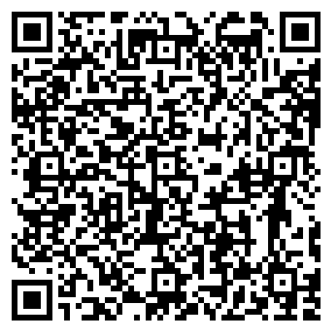
I. Basic Registration Information:
Eligibility: High school students recognized by the school
Number limit: Each school can recommend up to 5 posters
Submission link: Please scan the QR code on the right
Registration method: The information of the posters and their
first author should be provided by leading teacher of each high school.

II. Important Dates:
May 12 - July 20: Register and submit posters
July 21 - July 30: Poster review
July 31 - August 8: Announcement of shortlisted posters and public display
August 19 - August 21: High School Student Poster Exhibition

III. Benefits to Selected Schools and Students:
⚫ Experience firsthand the ICBS ambiance, inspiring scientific exploration and innovative thinking.
⚫ Showcase student achievements.
⚫ Engage in discussions with leading international scientists.
⚫ Receive the outstanding high school poster certificate with Congress Chairman Prof. Shing-Tung Yau's signature.
⚫ Be exempted from ICBS registration fees.
⚫ Enjoy complimentary self-service lunch and dinner.
⚫ Be recommended for participation in the 2026 Shing-Tung Yau High School Science Award Competition, upon approval by the organizing committee.
⚫ Be selectively recommended for publication in the Cambridge Journal for Junior Scientists.

IV. Materials and Requirements for Evaluation:
⚫ Submission details: Include information of the first student authors and their leading teacher from the high school.
⚫ Poster language: English.
⚫ Content: Poster should describe the student's original research project. If the research has already been published, the corresponding paper can also be submitted.
⚫ Specifications: Poster should be limited to 1-2 pages, 100cm (Height) x 80cm (Width), with file size less than 50M, including text, formulas, and illustrations.
⚫ Total selection: up to 100 outstanding research works will be selected from the submitted posters.
⚫ Document format: PDF file.

V. Instructions:
1. Participating posters must be submitted through the website above for online registration. Written submissions will not be considered valid.
2. Once confirmed, submitted information cannot be changed.
3. Posters that have won awards before cannot be resubmitted.
4. Research projects that have already received the S.-T. Yau High School Science Award are not eligible for submission.
5. Methods and conclusions taken from others' research should be cited and listed in the references.
6. Research must follow internationally recognized ethical guidelines and adhere to basic ethical requirements.
7. Please submit all participating information truthfully. If found to violate the principle of integrity, for example the participating poster is found to be fully plagiarized or ghost written, once verified.
Email：posterhighschool@bimsa.cn

